**Attaching EBS Volumes in EC2 Instance through Terraform**

**Terraform File:**



**AWS Console Steps:**

**Check the Configuration**

**Instance->**



**As we can see we have attached the EBS-Volume of dev/xvdb as external drive to mount in the windows server.**

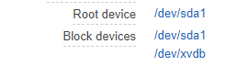

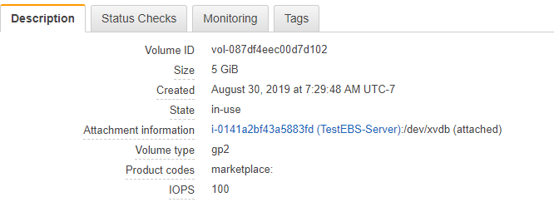

**WINDOWS INSTANCE:  
  
Steps:**

Go to Instance -> Disk Management(diskmgmt.msc) -> Make it Online -> Initialize Disk

-> New Simple Volume -> Give Volume Name (D: or XYZ:)

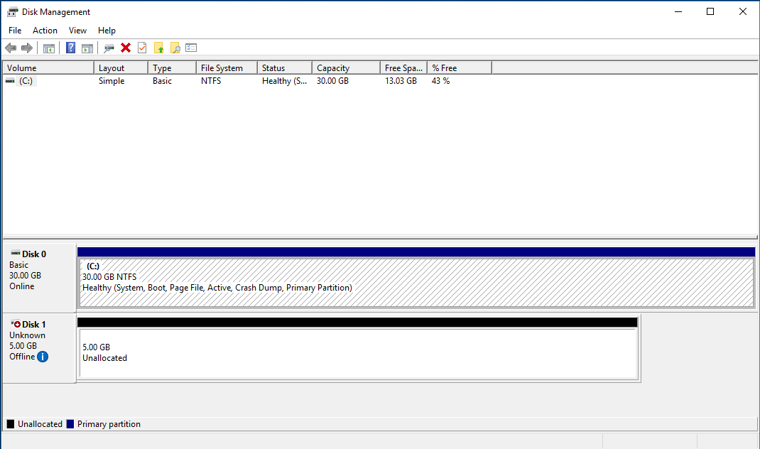

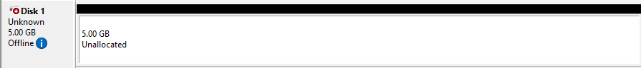

We need to make this drive **‘ONLINE’.**

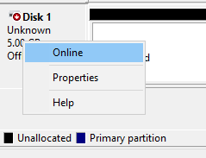

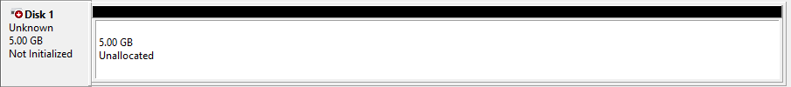

Then Initialize the Disk

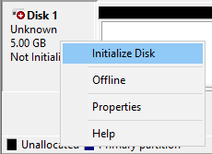

Came Online, But Unallocated.

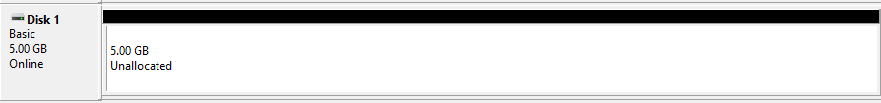

Right CLICK on Volume -> New Simple Volume

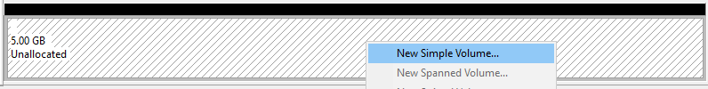

Assign Drive Letter to Drive, choose the format of Volume (Default is **NTFS**)

